## PROGRAM DEFINITION

|  |
| --- |
|  |
| * Program untuk inquiry data unit |

## RELATED TABLES

|  |  |
| --- | --- |
|  | **Access** |
| * PMM_TENANT | * RW |

## ROLES

|  |  |
| --- | --- |
|  | **Test** |
| * User yg mempunyai akses ke program |  |

## INITIAL PROCESS

|  |  |
| --- | --- |
|  | **Test** |
| * Set VAR_COMPANY_ID = Login User’s Company ID * Set VAR_USER_ID = Login User ID * Set VAR_LANGUAGE_ID = Login User’s Language ID * Get Property List to Combobox Property [PROPERTY_LIST]:   EXEC RSP_GS_GET_PROPERTY_LIST ‘VAR_CCOMPANY_ID’, ‘VAR_USER_ID’  Set Value : CPROPERTY_ID Set Display : CPROPERTY_NAME  As Parameter: CPROPERTY_ID |  |

## UNIT LIST

### USER INTERFACE

----- CR2 ----- Detail Tab Utility (desain grid tetap, hanya dirubah dgn tab)

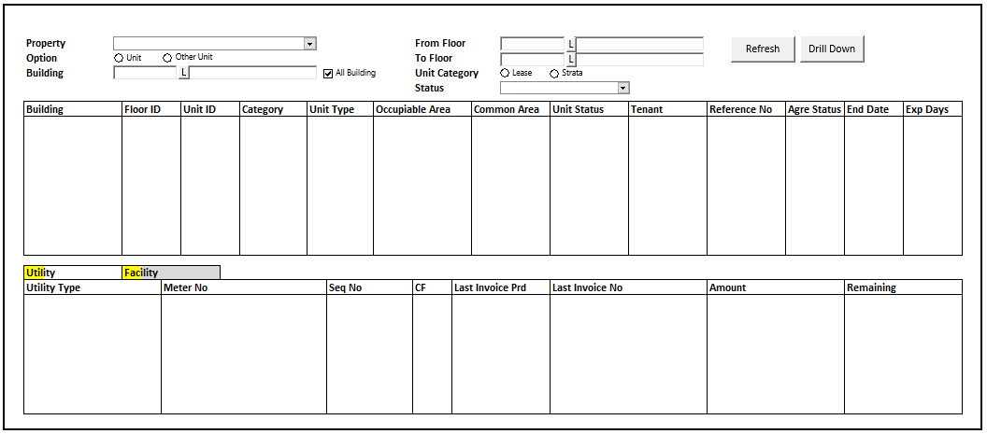

----- CR2 ----- Detail Tab Facility

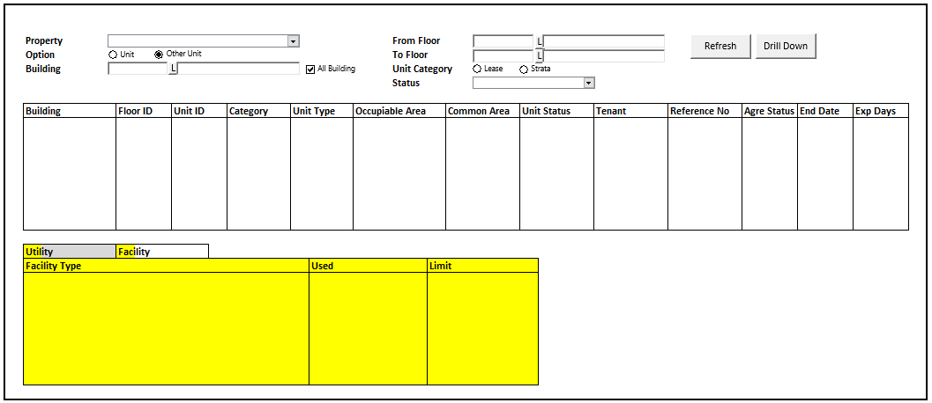

----- CR1 -----

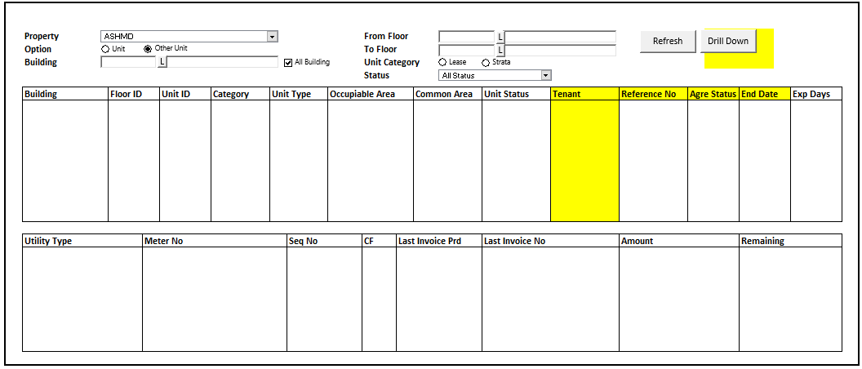

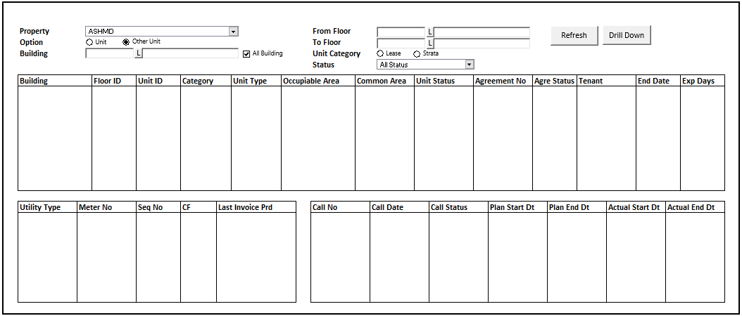

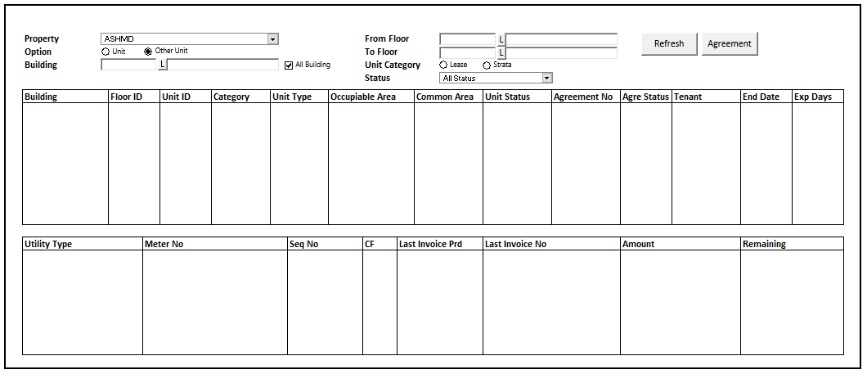

#### BUTTON DEFINITION ----- CR1 -----

|  |  |
| --- | --- |
| **Button Name** | **Action** |
| ~~Agreement~~  Drill Down | Enabled saat grid tidak kosong. Open Form ‘AGREEMENT_FORM’ Parameter:   * Property Id = **VAR_CLAST_FILTER_PROP_ID** * Property Name = **VAR_CLAST_FILTER_PROP_NAME** * Building Id * Building Name * Floor Id |
| Refresh | Untuk Refresh Data Grid Inquiry (Always enabled) |

#### INITIAL PROCESS

|  |  |
| --- | --- |
|  | **Test** |
| * Get Property List to Combobox Property [PROPERTY_LIST]:   EXEC RSP_GS_GET_PROPERTY_LIST ‘VAR_CCOMPANY_ID’, ‘VAR_USER_ID’  Set Value : CPROPERTY_ID Set Display : CPROPERTY_NAME  As Parameter: CPROPERTY_ID  Set Default Value when Open Program : Data Paling atas dr Combobox (index 0)   * Building = Do Lookup GSL02200 Parameter:   + VAR_COMPANY_ID   + Selected Property   + True   + VAR_USER_ID   Set Default Value when Open Program : Data Paling atas dr lookup | S |

#### DISPLAY PROCESS

##### HEADER FIELD DEFINITION

|  |  |  |  |
| --- | --- | --- | --- |
| **Name** | **Field** | **Type** | **Validation** |
| Property | Value: CPROPERTY_ID Display: CPROPERTY_NAME | Combobox | * Always Enabled * Mandatory |
| Option Unit | CUNIT_OPTION | Radio Button | * Always Enabled * Default Value after Open = Checked * IF Checked THEN   + Building = Mandatory   + Checkbox All Building = Disabled   + Checkbox All Building = Unchecked   + Set CUNIT_OPTION = “01” |
| Option Other Unit | CUNIT_OPTION | Radio Button | * Always Enabled * IF Checked THEN   + Checkbox All Building = Enabled   + Set CUNIT_OPTION = “02” |
| Building | * CBUILDING_ID * CBUILDING_NAME * Value : CBUILDING_ID | Textbox & Button Lookup | * Building Name always disabled * Building Id & button lookup Enabled when option = Unit OR (option = Other Unit AND All Building = unchecked) * Do Lookup GSL02200 Parameter:   + VAR_COMPANY_ID   + Selected Property ID   + True   + VAR_USER_ID * Set CBUILDING_ID = lookup.CBUILDING_ID * Set CBUILDING_NAME = lookup.CBUILDING_NAME |
| All Building | LALL_BUILDING | Checkbox | * Enabled when option = Other Unit * Default Value when Option: Unit = Unhecked * Default Value when Option: Other Unit = Checked * IF Checked THEN   + Building Textbox & Button Lookup = Disabled   + Building Textbox Value = “” * ELSE   + Building Textbox & Button Lookup = Enabled |
| From Floor | * CFROM_FLOOR_ID * CFROM_FLOOR_NAME * Value : CFROM_FLOOR_ID | Textbox & Button Lookup | * Floor Name always disabled * Floor Id & button lookup Enabled when option = Unit OR (option = Other Unit AND All Building = unchecked) * Do Lookup GSL02400 Parameter:   + VAR_COMPANY_ID   + Selected Property ID   + Selected Building ID   + True   + VAR_USER_ID * Set CFROM_FLOOR_ID = lookup.CFLOOR_ID * Set CFROM_FLOOR_NAME = lookup.CFLOOR_NAME |
| To Floor | * CTO_FLOOR_ID * CTO_FLOOR_NAME * Value : CTO_FLOOR_ID | Textbox & Button Lookup | * Floor Name always disabled * Floor Id & button lookup Enabled when option = Unit OR (option = Other Unit AND All Building = unchecked) * Do Lookup GSL02400 Parameter:   + VAR_COMPANY_ID   + Selected Property ID   + Selected Building ID   + True   + VAR_USER_ID * Set CFROM_FLOOR_ID = lookup.CFLOOR_ID * Set CFROM_FLOOR_NAME = lookup.CFLOOR_NAME |
| Unit Category Lease | CUNIT_CATEGORY | Radio Button | * Always Enabled * Default Value after open = Checked * IF Checked THEN   Set CUNIT_CATEGORY = “01”  ----- CR1 -----   * Refresh Combobox Status on Toggle Changed between Lease and Strata * Set Data Combobox CCODE = “00” AND CDESCRIPTION = “All Status”   Add Data Combobox yg sudah ada CCODE = “00” sblmnya dengan hasil Query:  EXEC RSP_PMI00300_GET_LS_STATUS_LIST dgn Parameter:   * + VAR_COMPANY_ID   + Selected Property Id   + 'L’   + VAR_USER_ID   Hasil :   * + Set CSTATUS_ID = CCODE   + Set CSTATUS_NAME = CNAME   + Set Default Value After Open Program / After Changed ‘Unit Category’ to All Status |
| Unit Category Strata | CUNIT_CATEGORY | Radio Button | * Always Enabled * IF Checked THEN   Set CUNIT_CATEGORY = “02”  ----- CR1 -----   * Refresh Combobox Status on Toggle Changed between Lease and Strata * Set Data Combobox CCODE = “00” AND CDESCRIPTION = “All Status”   Add Data Combobox yg sudah ada CCODE = “00” sblmnya dengan hasil Query:  EXEC RSP_PMI00300_GET_LS_STATUS_LIST dgn Parameter:   * + VAR_COMPANY_ID   + Selected Property Id   + 'S’   + VAR_USER_ID   Hasil :   * + Set CSTATUS_ID = CCODE   + Set CSTATUS_NAME = CNAME   Set Default Value After Open Program / After Changed ‘Unit Category’ to All Status |
| Status | * CSTATUS_ID * Display: CSTATUS_NAME * Value: CSTATUS_ID | Combobox | * Always Enabled   ----- CR1 -----   * Based on pilihan Unit Category Lease atau Strata pada radio button |
|  |  |  |  |

##### GRID FIELD DEFINITION GRID HEADER (VIEW ONLY)

|  |  |  |  |
| --- | --- | --- | --- |
| **Name** | **Field** | **Type** | **Validation** |
| Building | CBUILDING_NAME | Textbox |  |
| Floor ID | CFLOOR_ID | Textbox |  |
| Unit ID | CUNIT_ID | Textbox |  |
| Category | CCATEGORY | Textbox |  |
| Unit Type | CUNIT_TYPE_ID | Textbox |  |
| Occupiable Area | NOCCUPIABLE_AREA | Decimal | Thousand separator & Decimal Places 2 |
| Common Area | NCOMMON_AREA_SIZE | Decimal | Thousand separator & Decimal Places 2 |
| Unit Status | CUNIT_STATUS | Textbox |  |
| Tenant | CTENANT | Textbox |  |
| ~~Agreement No~~  Reference No | CAGREEMENT_NO | Textbox | ----- CR1----- |
| Agree Status | CAGREEMENT_STATUS | Textbox |  |
| End Date | DEND_DATE | Datetime |  |
| Exp Days | IEXP_DAYS | Decimal | Thousand separator & Decimal Places 0 |

##### GRID FIELD DEFINITION GRID DETAIL LEFT (VIEW ONLY) (CR2 taruh pada Detail Tab 1)

|  |  |  |  |
| --- | --- | --- | --- |
| **Name** | **Field** | **Type** | **Validation** |
| Utility Type | CUTILITY_TYPE | Textbox |  |
| Meter No | CMETER_NO | Textbox |  |
| Seq No | CSEQ_NO | Textbox |  |
| CF | CF | Textbox |  |
| Last Invoice Prd | CLAST_INVOICE_PRD | Textbox |  |
| Last Invoice No | CLAST_INVOICE_NO | Textbox |  |
| Amount | NAMOUNT | Decimal | **Decimal places 2** |
| Remaining | NREMAINING | Decimal | **Decimal places 2** |

##### CR2 GRID FIELD DEFINITION GRID DETAIL FACILITY (VIEW ONLY) (taruh pada Detail Tab 2)

|  |  |  |  |
| --- | --- | --- | --- |
| **Name** | **Field** | **Type** | **Validation** |
| Facility Type | CFACILITY_TYPE | Textbox |  |
| Used | IUSED | Decimal | **Decimal places 0** |
| Limit | ILIMITED | Decimal | **Decimal places 0** |
|  |  |  |  |
|  |  |  |  |
|  |  |  |  |
|  |  |  |  |
|  |  |  |  |

##### GRID FIELD DEFINITION GRID DETAIL RIGHT (VIEW ONLY)

|  |  |  |  |
| --- | --- | --- | --- |
| **~~Name~~** | **~~Field~~** | **~~Type~~** | **~~Validation~~** |
| ~~Call No~~ | ~~CCALL_NO~~ | ~~Textbox~~ |  |
| ~~Call Date~~ | ~~DCALL_DATE~~ | ~~Datetime~~ |  |
| ~~Call Status~~ | ~~CCALL_STATUS~~ | ~~Textbox~~ |  |
| ~~Plan Start Dt~~ | ~~DPLAN_START_DT~~ | ~~Datetime~~ |  |
| ~~Plan End Dt~~ | ~~DPLAN_END_DT~~ | ~~Datetime~~ |  |
| ~~Actual Start Dt~~ | ~~DACTUAL_START_DT~~ | ~~Datetime~~ |  |
| ~~Actual End Dt~~ | ~~DACTUAL_END_DT~~ | ~~Datetime~~ |  |

##### VALIDATION

|  |  |  |
| --- | --- | --- |
| **Field** | **Condition** | **Validation Message** |
| Property | Empty | Please select Property ! |
| Building | Empty | IF ALL Building = Unchecked THEN  Please select Building ! |

#### REFRESH PROCESS

#### ACTION

|  |
| --- |
|  |
| * Set Global Variable **VAR_CLAST_FILTER_PROP_ID** = Selected Property Id, **VAR_CLAST_FILTER_PROP_NAME =** Selected Property Name * Refresh Grid Header dengan RSP_PM_GET_UNIT_INQUIRY_HD dengan parameter   + VAR_COMPANY_ID   + Selected Property (CPROPERTY_ID)   + CUNIT_OPTION   + Selected Building Id (CBUILDING_ID)   + All Building Checked (LALL_BUILDING)   + Selected From Floor Id (CFROM_FLOOR_ID)   + Selected To Floor Id (CTO_FLOOR_ID)   + CUNIT_CATEGORY   + CSTATUS_ID   + VAR_LANGUAGE_ID * IF Grid Header isnot Nothing THEN   + Refresh Grid Detail (Bottom Left) dengan RSP_PM_GET_UNIT_INQUIRY_DT dengan parameter     - VAR_COMPANY_ID     - Selected Property (CPROPERTY_ID)     - CUNIT_OPTION     - Selected Building Id From Grid Header     - Selected Floor Id From Grid Header     - Selected Unit Id From Grid Header     - “1”     - VAR_LANGUAGE_ID   CR2 Grid Facility   * + Refresh Grid pada tab Facility dengan RSP_PM_GET_FACILITY_UNIT_INQUIRY dengan parameter     - VAR_COMPANY_ID     - Selected Property (CPROPERTY_ID)     - Selected Tenant Id From Grid Header     - Selected Building Id From Grid Header     - Selected Floor Id From Grid Header     - Selected Unit Id From Grid Header     - VAR_LANGUAGE_ID      * + ~~Refresh Grid Call (Bottom Right) dgn RSP_PM_GET_UNIT_INQUIRY_DT dgn parameter~~     - ~~VAR_COMPANY_ID~~     - ~~Selected Property (CPROPERTY_ID)~~     - ~~CUNIT_OPTION~~     - ~~Selected Building Id From Grid Header~~     - ~~Selected Floor Id From Grid Header~~     - ~~Selected Unit Id From Grid Header~~     - ~~“2”~~     - ~~VAR_LANGUAGE_ID~~ |
|  |

### USER INTERFACE AGREEMENT_FORM

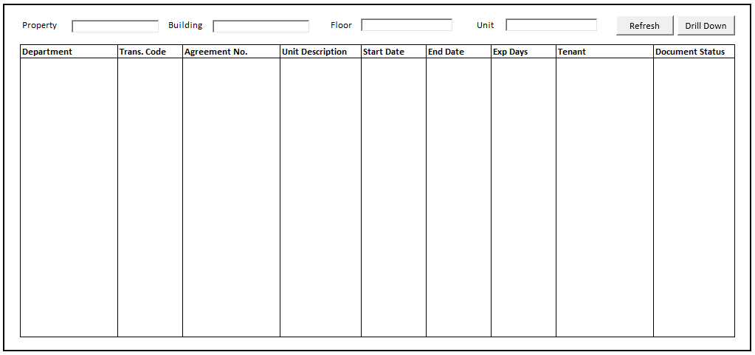

----- CR1 -----

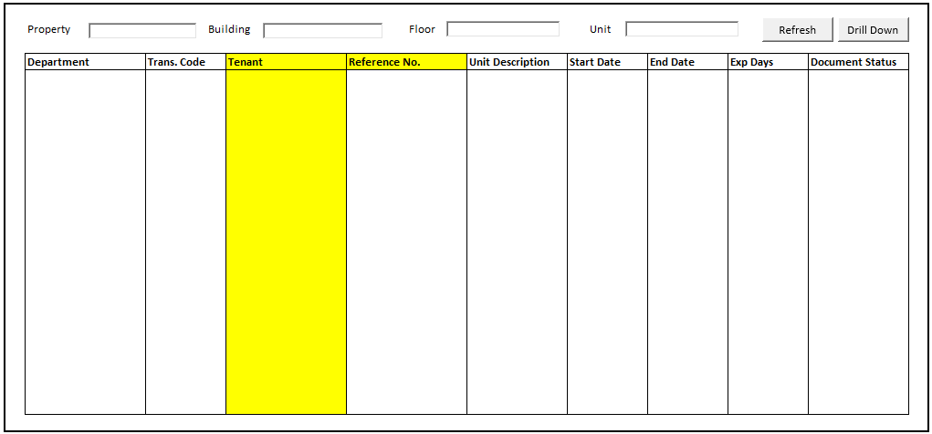

----- CR 4 -----

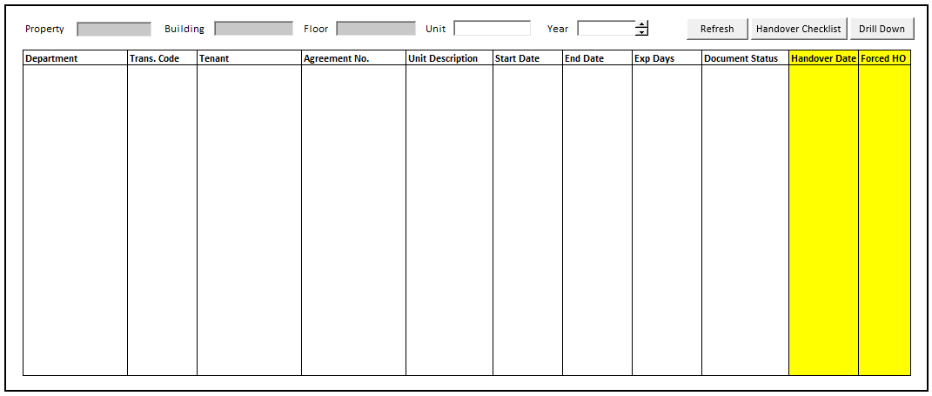

#### BUTTON DEFINITION

|  |  |
| --- | --- |
| **Button Name** | **Action** |
| Drill Down | Enabled saat grid tidak kosong. Open Form Program tertentu, base on Trans. Code. (VIEW ONLY)  802030 : PMT02500 Lease Agreement Unit  802032 : PMT02610 Lease Agreement Casual  802033 : PMT02700 Lease Agreement Event  802061 : PMT01300 LOI Unit  802062 : PMT01600 LOI Casual  802063 : PMT01900 LOI Event  CR3  802010 : PMT00300 LOI Strata Unit 802013 : PMT00400 Agreement Strata Unit 802020 : PMT00500 Ownership Manager. |
| Refresh | Untuk Refresh Data Grid Inquiry (Always enabled)   * Do Refresh Grid dengan RSP_PM_GET_UNIT_AGREE_FORM_LIST dengan parameter   + VAR_COMPANY_ID   + Form1.Property Id   + Form1.Building Id   + Textbox Floor Id   + Textbox Unit (default open ‘’)   + VAR_LANGUAGE_ID |
| Handover Checklist  **[CR04]** | Enabled saat LHO_CHECKLIST = TRUE  Jalankan HANDOVER CHECKLIST PROCESS  Kirim Parameter:   * CHO_DEPT_CODE * CHO_TRANS_CODE * CHO_REF_NO * CPROPERTY_ID * CUNIT_ID |

#### INITIAL PROCESS

|  |  |
| --- | --- |
|  | **Test** |
| Set Textbox Property : Form1.Property Name Set Textbox Building : Form1.Building Name  Set Textbox Floor : Form1.Floor Id   * Do Refresh Grid dengan RSP_PM_GET_UNIT_AGREE_FORM_LIST dengan parameter   + VAR_COMPANY_ID   + Form1.Property Id   + Form1.Building Id   + Textbox Floor Id   + Textbox Unit (default open ‘’)   + VAR_LANGUAGE_ID |  |

#### DISPLAY PROCESS

|  |  |  |  |
| --- | --- | --- | --- |
| **Name** | **Field** | **Type** | **Validation** |
| Property | Display: Form1.Property Name | Textbox | * Always Disabled |
| Building | Display: Form1.Building Name | Textbox | * Always Disabled |
| Floor | Display: Form1.Floor Id | Textbox | * Always Disabled |
| Unit | CUNIT_ID | Textbox | * Always Enabled |

##### GRID FIELD (VIEW ONLY)

|  |  |  |  |
| --- | --- | --- | --- |
| **Name** | **Field** | **Type** | **Validation** |
| Department | CDEPARTMENT | Textbox |  |
| Trans. Code | CTRANS_CODE | Textbox |  |
| Tenant | CTENANT | Textbox |  |
| ~~Agreement No.~~  Reference No. | CAGREEMENT_NO | Textbox |  |
| Unit Description | CUNIT_DESCRIPTION | Textbox |  |
| Start Date | CSTART_DATE | Datetime | Convert to Date |
| End Date | CEND_DATE | Datetime | Convert to Date |
| Exp Days | IEXPIRED_DAYS | Decimal | Decimal Places 0 |
| Document Status | CDOCUMENT_STATUS | Textbox |  |
| Handover Date  **[CR04]** | CHO_ACTUAL_DATE | Datetime | Convert to Date |
| Forced HO  **[CR04]** | LFORCED_HO | Checkbox |  |
| HO DEPT CODE  **[CR04]** | CHO_DEPT_CODE | Hidden |  |
| HO TRANS CODE  **[CR04]** | CHO_TRANS_CODE | Hidden |  |
| HO REF NO  **[CR04]** | CHO_REF_NO | Hidden |  |
| HO CHECKLIST  **[CR04]** | LHO_CHECKLIST | Hidden |  |

#### HANDOVER CHECKLIST PROCESS **[CR04]**

##### USER INTERFACE

##### INITIAL VERSION

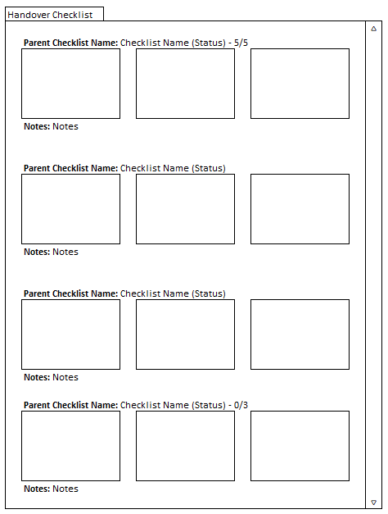

##### BUTTON DEFINITION

|  |  |  |
| --- | --- | --- |
| **Button Name** | **Action** | **Enabled** |
|  |  |  |

##### INPUT PARAMETER

|  |  |
| --- | --- |
| **Parameter Name** | **Description** |
| PARAM_HO_DEPT_CODE | VAR_SELECTED.CHO_DEPT_CODE dari Grid di Agreement Form |
| PARAM_HO_TRANS_CODE | VAR_SELECTED.CHO_TRANS_CODE dari Grid di Agreement Form |
| PARAM_HO_REF_NO | VAR_SELECTED.CHO_REF_NO dari Grid di Agreement Form |
| PARAM_PROPERTY_ID | VAR_SELECTED.CPROPERTY_ID dari Grid di Agreement Form |
| PARAM_UNIT_ID | CUNIT_ID dari Textbox Filter di Agreement Form |

##### ROLES

|  |  |
| --- | --- |
|  | **Test** |
| * User yg punya akses ke program |  |

##### INITIAL PROCESS

|  |  |
| --- | --- |
|  | **Test** |
| * Load data from Input Parameter * **Load Handover Unit Checklist List**   Jalankan RSP_PM_GET_HANDOVER_CHECKLIST_LIST dengan parameter, simpan hasil ke VAR_HANDOVER_CHECKLIST_LIST   * + VAR_COMPANY_ID   + PARAM_PROPERTY_ID   + PARAM_HO_DEPT_CODE   + PARAM_HO_TRANS_CODE   + PARAM_HO_REF_NO   + PARAM_UNIT_ID |  |

##### DISPLAY PROCESS

##### FIELD DEFINITION

|  |  |  |  |
| --- | --- | --- | --- |
| **Name** | **Field** | **Type** | **Validation** |
| **Popup** |  |  | Width: Auto  Height: Auto |
| **Scrollable Area** |  |  | Width: 800px  Height: 500px |
| **Checklist List** | For each item in VAR_HANDOVER_CHECKLIST_LIST, create Checklist Card | **Data:** VAR_HANDOVER_CHECKLIST_LIST |  |
| **Checklist Card** |  |  |  |
| Checklist Title | CPARENT_CHECKLIST_NAME  CCHECKLIST_ITEM_NAME  LSTATUS  IACTUAL_QUANTITY  IBASE_QUANTITY  Set CSTATUS =  If LSTATUS = TRUE, then “OK”  Else if LSTATUS = FALSE, then “Not OK” | Label | IF IBASE_QUANTITY = 0, then  Display “**CPARENT_CHECKLIST_NAME:** CCHECKLIST_ITEM_NAME (CSTATUS)”  Example:  “**Dapur:** Dapur Kotor (OK)”  Else IF IBASE_QUANTITY > 0, then  Display “**CPARENT_CHECKLIST_NAME:** CCHECKLIST_ITEM_NAME (CSTATUS) – IACTUAL_QUANTITY/IBASE_QUANTITY”  Example:  “**Piring:** Piring Bulat (Not OK) – 3/5” |
| Checklist Image  (Justify Space Between) | CIMAGE_STORAGE_ID_01 | ImageBox  ImageBoxType = Zoom | MaxWidth: 250px  MaxHeight: 200px  On Clicked,  Go to 🡪 ZOOM IMAGE PROCESS |
| CIMAGE_STORAGE_ID_02 | ImageBox  ImageBoxType = Zoom | MaxWidth: 250px  MaxHeight: 200px |
| CIMAGE_STORAGE_ID_03 | ImageBox  ImageBoxType = Zoom | MaxWidth: 250px  MaxHeight: 200px |
| Notes | CNOTES | Label | IF CNOTES = “”, then “**Notes:** -“  Else “**Notes:** (CNOTES)” |

##### CLOSE PROCESS

###### ACTION

|  |
| --- |
|  |
| * Close this POPUP |
|  |

# CR LIST

|  |  |  |
| --- | --- | --- |
| **CR** | **Description** | **Notes** |
| CR1 | * Rubah Display dan Combobox Status |  |
| CR2 | * Rubah Detail Utility menggunakan tab (tab 1 utk Utility & tab 2 utk grid baru Facility) |  |
| CR3 | * Tambah kode program yg bisa d buka lewat Drill Down |  |
| CR4 | * Menambahkan Handover Checklist |  |

#### TEMPLATE

#### VALIDATION

|  |  |  |
| --- | --- | --- |
| **Field** | **Condition** | **Validation Message** |
|  |  |  |
|  |  |  |

#### ACTION

|  |
| --- |
|  |
|  |